INSTITUCION EDUCATIVA MARIA DORALIZA LOPEZ DE MEJIA
RIOHACHA, LA GUAJIRA

DOCENTE: CLAUDIA CANTILLO GOMEZ
Celular: 3012638139
e-mail: ccantillo@inemadol.edu.co EIGHTH GRADE. 8-01-02-03-04.

GUIA#4

ACTIVITY IN CLASS. CLASIFY THE WORDS ACCORDING THE CATEGORIES, THEN COLOR THEM: NOUNS-YELLOW, VERBS-GREEN, ADJECTIVES-BLUE.
PLAYS WATCH IS AREN´T
WEEK BAD ONE GYM NUTRIENTS ISN´T
GAMES MUSICAL ORANGE
HAPPY DOG BONES
TV VEGETABLES AM INTELLIGENT GONE
BIKE DID SHOWER DO
TOMATOES UGLY SAD
SCHOOL HELP POT BANANAS DOES
EGGS HAS APPLE
STUDIES CEREALS RUDE ANGRY FRUITS CAT

WRITE: ADJECTIVES VERBS NOUNS
1.
2.
3.
4.
ACTIVITY 2 ORDER THE WORDS TO MAKE QUESTIONS AND MATCH THEM WITH AN ANSWER. Page 8 WAY TO GO WORKBOOK.

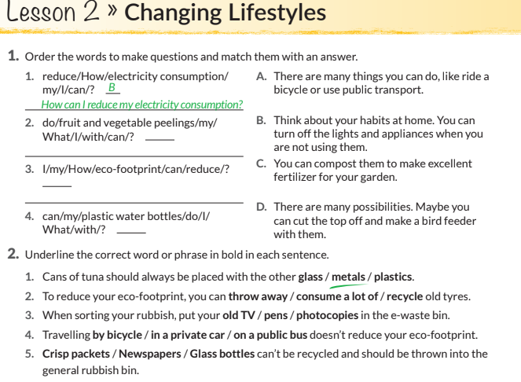
VOCABULARY. SELECT A LIST OF WORDS.
Crisp packets
newspapers
glass bottles
public bus
by bicycle
recycle
pen
photocopies
ACTIVITY 3 LOOK AT THE INFORMATION.
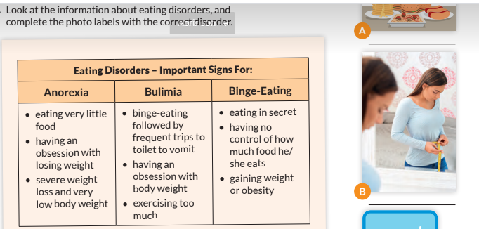
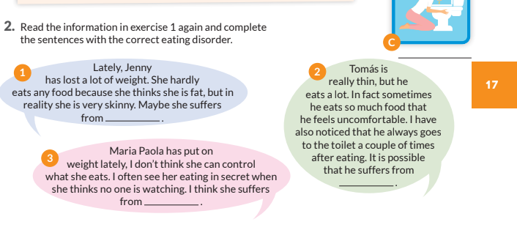
VOCABULARY. SELECT A LIST OF WORDS.
PUT ON SKINNY
OFTEN HARDLY
WATCHING MAYBE
SUFFER LOST
UNCOMFORTABLE BECAUSE
ACTIVIDAD 4. PERSONAL INFORMATION.
MAKE A BIOGRAPHY ABOUT YOU /FAMOUS PEOPLE.

2. FAMILY TREE.
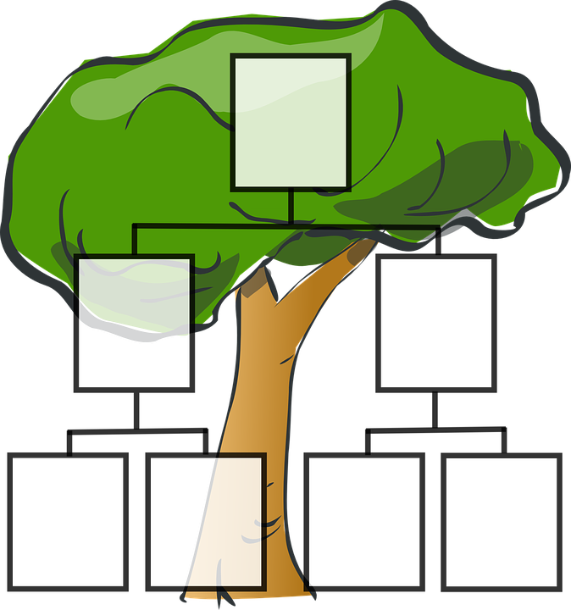
TELL ME ABOUT YOUR FAMILY.

3. MAKE A CONVERSATION IN VIDEO.

https://youtu.be/sk-XP4-CvhM
https://www.youtube.com/watch?v=sk-XP4-CvhM
ESTE LINK LOS LLEVA A UNA CONVERSACIÓN CORTA EN INGLES PARA QUE LA PRACTIQUEN CON UN FAMILIAR Y HACEN EL VIDEO CONVERSANDO EN INGLÉS.
LA ACTIVIDAD #5 ES UN QUIZZ QUE LES HARÉ LLEGAR CON LA ACTIVIDAD #4 A CLASSROOM TIENEN HASTA EL 20 DE SEPTIEMBRE PARA REALIZAR TODA LA GUIA CON EL QUIZZ.
ACTIVIDAD #5 QUIZZ https://forms.gle/5L18sCF7HjoUtRn36

