INSTITUCION EDUCATIVA MARIA DORALIZA LOPEZ DE MEJIA COORDINACIÓN ACADÉMICA
DISTRITO DE RIOHACHA – LA GUAJIRA CÓDIGO DANE: 144001000138 NIT. 825000393
Planificación Didáctica de la Clase Virtual 2020
Guía #4 7-03-04-05
Docente: CLAUDIA CANTILLO GOMEZ
CORREO ELECTRÓNICO: ccantillo@inemadol.edu.co

- ACTIVITY IN CLASS. CLASSIFY THE WORDS ACCORDING THE CATEGORIES, THEN COLOR THEM: NOUNS: PINK- VERBS: GREEN,- ADJECTIVES-BLUE.

UMBRELLA DOES UGLY ONE IS APPLE

STUDIES SHORT HOUSE ANNE AM DID

HAPPY PLAYS CAR BARRANQUILLA
AREN´T BOYS DARK CITY NAME GONE

IMPORTANT RIOHACHA SCHOOL GREEN TWO MUSICAL
TAKES PINEAPPLE SUSAN DO
EXCELLENT ORANGE VEGETABLES GOES

2. WRITE: VERBS NOUNS ADJECTIVES.

ACTIVITY 2: VERB CAN- CAN'T page 8 WAY TO GO- WORKBOOK.

3. WHAT SPORTS OR ACTIVITIES CAN OR CAN´T THESE PEOPLE DO? USE THE WORDS FROM THE BOX.
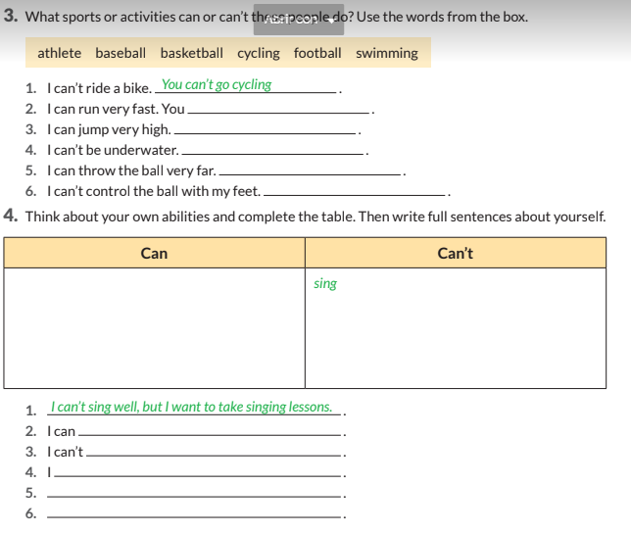
COMPLETE THE SENTENCES. PERSONAL PRONOUNS.
WHAT MEANS CAN:__________________________________________
CAN IS A___________________________________________________
- CAN______HELP ME¡ PLEASE.
- ____CAN SPEAK SPANISH.
- _____CAN PLAY SOCCER
- _____CAN USE A DRESS
- _____ CAN USE TIE.
- _______CAN RUN IN THE PARK.

ACTIVITY 3 LET´S GO TO READ SANTIAGO´S HYGIENE ROUTINE. PAGE 9
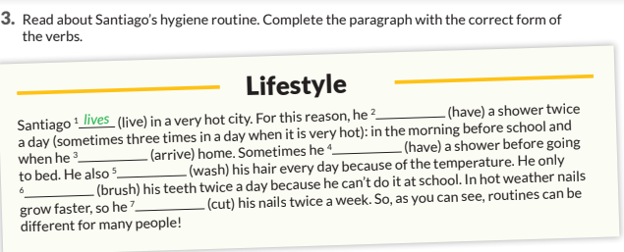

ANSWER THE QUESTIONS.

- WHERE SANTIAGO LIVES?________________________________________

- HOW OFTEN DOES SANTIAGO HAVE A SHOWER?_____________________________________

- HOW OFTEN DOES SANTIAGO BRUSH HIS TEETH?_______________________________________

- IN______WEATHER________GROW FASTER.

- SO_____CUTS HIS NAILS_________< WEEK.

ACTIVITY 4. PERSONAL INFORMATION .

- TELL ME ABOUT YOU.
- MAKE AN ACROSTIC WITH THE LETTERS´NAME.
- FAMILY TREE.
- STUDENT CARD.

FOR EXAMPLE:

- I AM SUSAN SMITH, I LIVE IN BARCELONA….

- So beautifull
Unique
Sensational
Amazing
Never forget it

- 
- STUDENT CAR

STUDENT CARD
NAME:
LAST NAME:
GRADE:
SCHOOL:
CITY:
PHONE:
ADDRESS:
AGE:

____________________________________
SIGNE.
CHICOS CON LA ACTIVIDAD 5 FINALIZAMOS LA GUIA #4 DE INGLÉS PARA LOS GRADOS 7-03-04-05.
ESTA GUÍA LA VAN A ENCONTRAR EN LA PLATAFORMA DE CLASSROOM Y TIENEN HASTA EL FIN DE SEMANA PARA ENVIARLA AL PROFESOR.
FECHA DE ENTREGA: 20 DE SEPTIEMBRE DE 2020.
LA ACTIVIDAD 5 ES UN QUIZZ DE INGLÉS QUE HARÁN EN UN FORMULARIO DE GOOGLE Y SOLO TENDRÁN UNA SOLA VEZ PARA RESPONDER.
SEE YOU THE NEXT CLASS, BYE.
CLAUDIA CANTILLO GOMEZ. teacher.
ENLACE QUIZZ https://forms.gle/KrCqy5ca3qFMMjkp7

